NetMeeting Overview

Getting Started

To get started with NetMeeting and our training session, you have to send me your IP address. You find your IP address on the help menu on the toolbar of
NetMeeting. You select “Help” from the menu bar and select the word, “About NetMeeting”. The menu opens up and at the bottom, it lists IP addresses. You then write down your IP address and send it to me via e-mail.

Process

- After I receive your e-mail, I begin the process of training you remotely.

- I will type in your IP address in the NetMeeting drop down box.

- 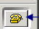 I will then select the telephone and call you.

- An invitation will be sent to you from NetMeeting.

- You accept the invitation.

- You select the 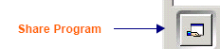 share icon and highlight the word Desktop in the screen under Share Programs and select the word share. Under the word Control, click on Allow Control and check mark “Automatically accept requests for control”.

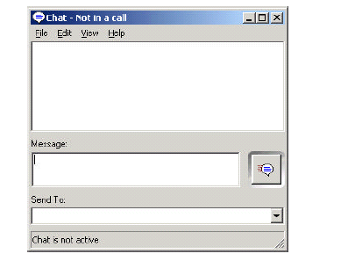
- You are now setup for NetMeeting.

- You will see me in NetMeeting window.

- If for any reason we lose communication, you can select the chat 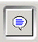 icon and it opens up to this screen. You enter a message for me in the message box. Prior to the training, I will give you my IP address. You enter it in the “Send To” box and select the “callout shape” that is next to the message box. I will see your message and respond back to correct the situation. Sometimes, we may have to start over again.

Audio and Video Enhancements

In using NetMeeting for you to see me, I have purchased a web camera. I also have a headset to talk to you. If you would like a web camera or microphone/headset to talk to me, we can discuss these details prior to our training session.

